**Interesting Trends from Statistical Data: 2020 Analysis of Malaria Elimination in Districts/Municipalities**

Dian Ayu Fauziah

22031554011

1. **INTRODUCTION**

Malaria is a major problem that is a challenge in tropical and sub-tropical countries, including Indonesia. Malaria is a disease caused by the *plasmodium parasite .* Female Anopheles *mosquitoes*  infected with *plasmodium* parasites can spread malaria through their bites. Indonesia as a tropical country still faces the problem of malaria because it has many places that are in accordance with the breeding place of anopheles mosquitoes (Pat del et al, 2005). In 2010 positive cases of malaria in Indonesia reached 465.7 thousand, while in 2020 positive cases decreased to 235.7 thousand. Not only that, the decrease in malaria cases was also followed by a decrease in Annual Parasite Incidence (API) which in 2010 reached 1.96 and 2020 reached 0.87[1] . Although the Annual Parasite Incidence (API) in the last decade in Indonesia has decreased, the figure shows stagnant conditions since 2014. With the Covid-19 pandemic, it is feared that this number will increase if there is no new approach or intervention . Global efforts to control and eliminate malaria are top of the global health agenda. Malaria elimination consists of 4 stages including eradication, pre-elimination, elimination and maintenance of malaria. Malaria maintenance activities include preventing malaria transmission by eradicating mosquito breeding sites, improving health services, preventing risk factors with protection against malaria, and Communication-Information and Education [2].

Medical expenses and transportation costs have become an economic burden for sufferers and their families arising from illness and death in endemic areas. The purpose of this article is to conduct an in-depth analysis of the number of districts and cities in a region that have successfully achieved malaria elimination status by 2020[3].

1. **LITERATURE REVIEW OF APPLICATION**

In statistics, the t-distribution was first derived as a posterior distribution, which is a type of conditional probability in Bayesian statistics. In common usage, the term posterior probability refers to the conditional probability of an event given which comes from an application of Bayes' theorem (Helmert, 1876). The t-test is a statistical hypothesis test in which the test statistic follows a student's t-distribution under then null hypothesis, it includes many types. There is one sample t test, used to compare the mean of a sample with an assumed value of the population, the two samples independent t -test, which can be used when the two groups under comparison are independent of each other, and the paired t- test, which can be used when the two groups under comparison are dependent on each other (McDonald, 2009, Katherine, Flannelly, & Flannelly, 2018, Mishra, Pandey, Singh, Gupta, Sahu, Keshri , 2019). The one sample t-test will be treated in detail, it is used to compare the mean of a sample with an assumed value of the population, the population mean is not always known but it is sometimes hypothesized[4].



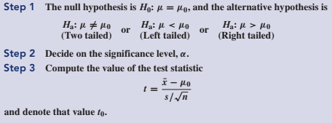

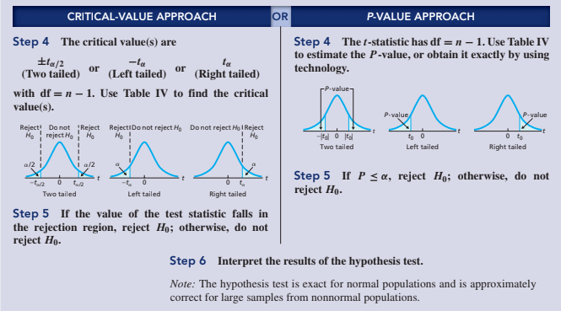

1. **DATA ANALYSIS AND DISCUSSION**

The first step is to find data to process using the population t test. After the data is obtained, then samples are taken by random sampling. Random sampling is taken based on the subjective view of the researcher.

**1.1**

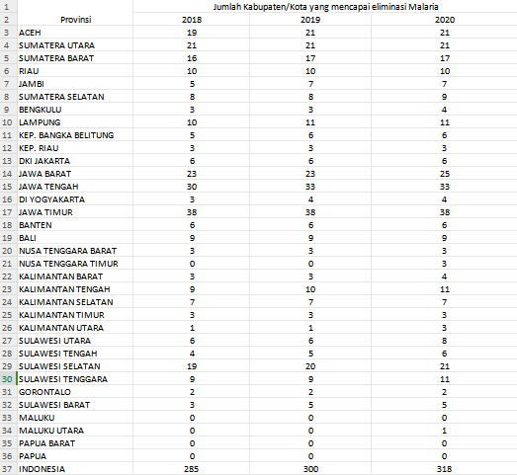

**Figure 1.1** is the original data taken from the website of the National Statistics Agency and the data has not been processed

**1.2**

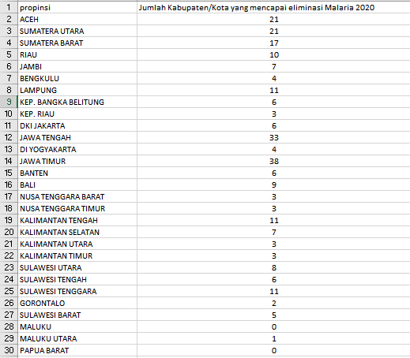

**Figure 1.2** is the data that will be used by researchers for processing

**1.3**

**Figure 1.3** is a random sample of population data taken randomly based on the subjective views of researchers

After taking a sample of population data, then the random sample data is calculated to find the value of the mean, standard deviation, and so on which will later be used to calculate the population t-test value.

Formula: 

Given cases:

The average value of the population data of the number of districts and cities that achieved malaria elimination in 2020 is 9.352

A study was conducted by taking 10 samples and obtained the average 2.6, and standard deviations 1,897

Will the sample regress or not compared to the population at a significant level of 0.05?

**Step 1** : Perform a hypothesis test

H0 : μ ≥ μ0

H1: μ < μ0

**Step 2** : Define Ttable

Ttabel, T(α, n-1) = T(0.05, 10-1) = T(0.05, 9)

=3.250

**Step 3** : Critical area (rejection H0, test one left side)

H0 is rejected if Tcalculate < - Ttabel

**Step 4** : Test statistics (Tcalculate)



Thit = -11.257

Because Tcalculate < -Ttable, H0 is rejected

So, the average number of districts and cities that reached the 2020 malaria elimination rate has regressed from the population average

**Calculate using Rstudio software**

Results are obtained as follows:

The calculation results using R Studio can be seen that p-value = 6.642e-07 and the significant level used is 0.05, it can be concluded that if the p-value is < α, so it rejects H0

**IV. CONCLUSION**

In conclusion, it has been mentioned that malaria elimination in 2020 increased but although the Annual Parasite Incidence (API) in the last decade in Indonesia has decreased, the figure shows stagnant conditions since 2014. With the Covid-19 pandemic, it is feared that this number will increase if there is no new approach or intervention.

Therefore, this study shows that the 2020 malaria elimination rate has regressed from the population average which makes conditions stagnant

**V. REFERENCES**

[1] “Kasus Malaria di Indonesia Menurun, NTT Jadi Provinsi Pertama di Kawasan Timur Berhasil Eliminasi Malaria – P2P Kemenkes RI.” Accessed: Oct. 17, 2023. [Online]. Available: http://p2p.kemkes.go.id/kasus-malaria-di-indonesia-menurun-ntt-jadi-provinsi-pertama-di-kawasan-timur-berhasil-eliminasi-malaria/

[2] B. Roosihermiatie and N. Lely Pratiwi, “ANALISIS IMPLEMENTASI KEBIJAKAN ELIMINASI MALARIA DI INDONESIA (Analysis of Implementation The Policy on Malaria Elimination in Indonesia),” *Review*, vol. 1, 2015.

[3] “WORLD MALARIA REPORT 2020,” 2020, Accessed: Oct. 17, 2023. [Online]. Available: https://www.wipo.int/amc/en/

[4] H. Pengembangan Aplikasi Uji-T … | Mustafidah, A. Imantoyo, and S. Suwarsito, “Pengembangan Aplikasi Uji-t Satu Sampel Berbasis Web(Development of Web-Based One-Sample t-Test Application),” *JUITA : Jurnal Informatika*, vol. 8, no. 2, pp. 245–251, Nov. 2020, doi: 10.30595/JUITA.V8I2.8786.

**VI. APPENDIX**

**2.1**

**Figure 2.1** is a manual calculation of the t one sample test

**2.2**

**Figure 2.2** is a manual calculation of hypothesis test using p-value

**2.3**

**Figure 2.3** is a graph of the conclusions of the two manual calculations above